Nepal College of Information Technology
Unit Test
Fall 2011
Program : BE CE Time : 2 hrs
Semester : Fall (III) FM : 65
Subject : Engineering Math-III PM : 33

- Candidates are requested to give their answer as far as practicable in their own words.
- The figure in the margin indicates the full marks
- Attempt ALL question
1. a) Define transpose of a matrix. If A an B are two matrices of specified order, prove that 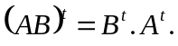 7
b) Prove that 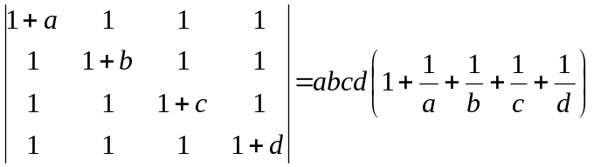 8
2. a) Solve by using Gauss elimination method:
x +2y +3z =26
-2x+3y-4z =-14
3x-7y+4z = 1 7
b) Define linearly independent and dependent set of vectors. Check are linearly independent or not. 8
3. a) Find rank of 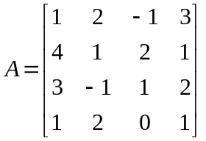 8
b) Check the system of equations 2x + 3y = 8 and 3x – y = 1 is consistent or inconsistent. If it is consistent, solve by cramer’s rule. 7
4. a) Let V = R³ be a vector space. Show that
W = { (x, y, o) : x, y R } is vector subspace of V. 5
b) Find eigen value and eigen vector of a matrix
A = 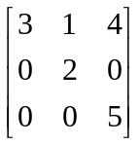 10
5. Attempt any two: 2.5*2=5
a) Without expanding, show that 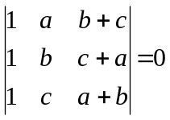
b) Find inverse of a matrix A = 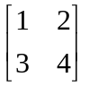
c) Find rank of A = 